[Company Name]

Key Performance Indicator Plan

Version: [0.0]
Date published: [Date]
Presented by: [Presenter’s Name]

Key Performance

Indicator Plan
The Key Performance Indicator (KPI) Plan helps you define the primary success indicators for your industry. KPIs are predetermined measurements that reflect the critical success factors of an organization. KPIs differ by organization, industry, and even by department. Use this template to identify the KPIs for your business.
This template provides an overview of the important tasks that you’ll need to perform to develop clear, useful KPIs. Following the overview is a more detailed guide of the information that you’ll need to consider when developing your KPIs.

Overview
A KPI is a measure designed to track a critical performance variable over time and provide a statistical measure of how well an organization is doing. KPIs should be few in number and focus on the product or service’s potential contribution to your business success.

VITAL AREAS TO CONSIDER

Financial metrics
[Company Name]
Gross profit
Percentage of sales increase
Jobs created
Numbers sold

Competition numbers
[Company Name]
Gross profit
Percentage of sales increase
Jobs created
Numbers sold

CHOOSE KEY PERFORMANCE INDICATORS
[List the KPIs that you want to track.]

1.
2.
3.
4.
5.

LIST KEY BUSINESS DRIVERS
[List your top three business drivers in the marketplace.]

1.
2.
3.

PRESENT KPIS GRAPHICALLY
[Show your KPIs in a graph or picture. You can create a graph in Excel and paste it here.]

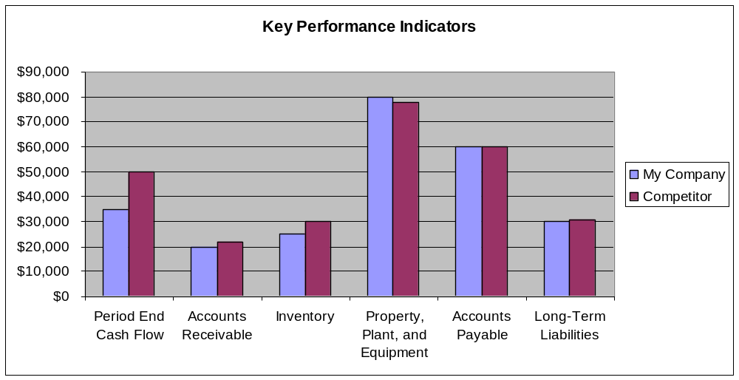

1. Monitor vital areas
Track important indicators that will give you insight into the direction that your company is headed. The following indicators can help you monitor and control the profitability and cash flow of your business. Add other indicators that relate to your business.

SALES
[Track any significant increase or decrease during a given time period.]

COSTS
[Are costs increasing more than revenue? Examine all costs, including labor, overhead, and warehousing and delivery.]

WORKING CAPITAL
[Derive working capital by subtracting current liabilities from current assets. Examining the three indicators in this section can help you identify trends toward cash flow problems or falling profitability.]

Current assets | Current liabilities | Working capital

2. Identify key drivers
List the critical elements that drive your business. The drivers listed cover costs and sales. You may need to add other drivers that are important to your business, such as customer service calls or process redundancy.

COST-EFFICIENCY ITEMS

Direct labor costs
[Direct labor costs often include “soft” factors like building new business relationships or developing effective networking.]

Indirect costs
[If you identified employee morale as a KPI, you can monitor items like voluntary overtime, absenteeism, and sick days. Remember that these drivers may change with time. Factors such as growth of your business, market share, or seasonal changes may change your indirect costs over time.]

SALES
KPIs for sales can include the following:

Enquiry levels
[Enquiry levels, such as the number of quotes given, will give you insight into which marketing campaigns work best.]

Order book entries
[Compare the total value of your order book to breakeven sales for one month. A six-month order book means that you can survive for six months without making another sale.]

Sales numbers
[Examine such factors as which product categories are selling well, achievements of each salesperson, or the change in your conversion rates (ratio of leads to sales).]

3. Choose key performance indicators
Focus on a handful of key indicators, including:
- Performance and progress of your business: These indicators can be tracked
by looking at such factors as increased market share, increased sales, and higher
employee morale.
- Measurable factors: KPIs that can be measured and monitored on a regular basis are the most effective.
- Actionable items: A KPI must have a clear action, such as improved employee retention or product performance.

4. Present your indicators
Plan a presentation of your KPIs that clearly illustrates how your goals will improve strategic success. Issues to consider when developing your presentation include:

PRESENTATION
[Specify how you would like to present your indicators. Visuals provide a quick overview of how your company is doing.]

FINANCIALS
[Always present actual figures alongside the standard figures for a good picture of your financial standing.]

RED LIGHTS
[Discuss a red-light system to alert your company to particular dangers or opportunities.]

